JS Advanced: Exam Preparation May 2020
Exam problems for the "JavaScript Advanced" course @ SoftUni. Submit your solutions in the SoftUni judge system at https://judge.softuni.bg/Contests/2458/Exam-Preparation-May-2020

Problem 1. Task Manager
Use the index.html and app.js files to solve this problem. You have NO permission to directly change the given HTML code (index.html file).
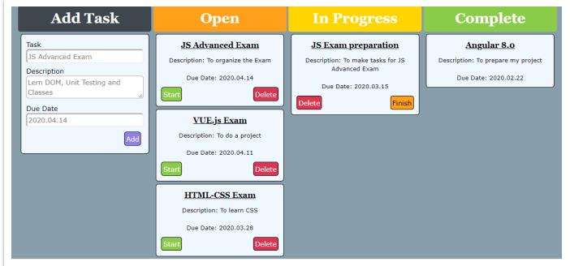

Your task
Write the missing JavaScript code to make the Task Manager Functionality works as follows:
When the Add button is clicked, first you need to validate the inputs. If any of the input fields is empty, the function doesn’t make anything.
After validating the input fields, you need to add the new task (article) in “Open” section.
The HTML structure looks like this:
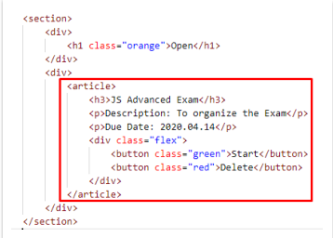
The article should have two buttons “Start” and “Delete”. Be careful to set the classes for the buttons and the parent-div.
When the “Start” button is clicked, you need to move the Task in the section “In Progress”. Be careful with the buttons! The HTML structure looks like this:
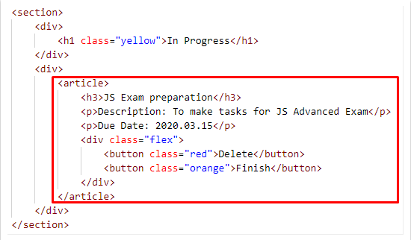
When the “Delete” button is clicked, the Task (whole article) should be removed from the HTML.
After clicking the “Finish” button, the Task will be completed, and you should move the article in the section “Complete”. The buttons with their parent div-element should be removed.
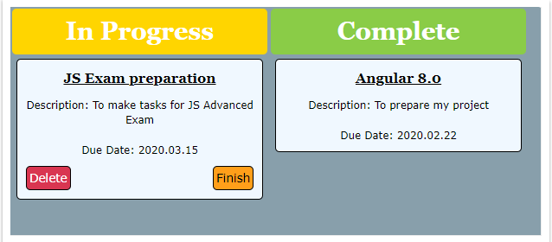
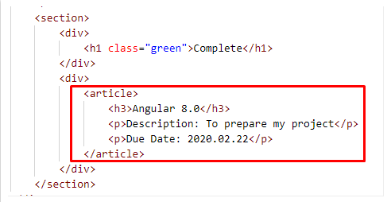

Submission
Submit your solution into a function.

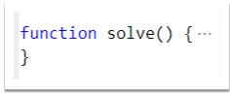

Problem 2. Press House

Your Task
Your need to create several classes for Press House. Implement the following classes:
Article, ShortReports, BookReview.

Article
constructor(title, content)
Should have these 2 properties:
- title – string
- content – string
toString()
This function should return the title and the content:
" Title: {title}
Content: {content}"

ShortReports
Class ShortReports inherits class Article.
constructor(title, content, originalResearch)
Should have these 4 properties:
- title – string,
- content – string,
- originalResearches – object with properties title and author
- comments – array of strings
As we create a short reports here we have a length limit for the content property – it should be less than 150 symbols, otherwise throw an error with the next message:
"Short reports content should be less then 150 symbols."
The property should have the both required properties , otherwise throw error with this message:
"The original research should have author and title."
addComment(comment)
This function should receive single comment like string, add it to the comments array and return a message:
"The comment is added."
toString()
This function should extend the toString method of class Article adding same more lines like:
"Original Research: { title } by { author }"
And if there are any comments you should print on a new line
"Comments:"
and then all comments each on a new line.
Note: For more information see the examples below!

BookRewiew
Class BookReview inherits class Article.
constructor(title, content, book)
Should have these 4 properties:
- title – string,
- content – string,
- book – object with properties name and author,
- clients – array of objects,
The client object should have the following structure {clientName, orderDescription}.
addClient(clientName, orderDescription)
This function should receive clientName and orderDescription as strings. Here you should check our clients array and if we already have this order from the same client throw error with next message:
"This client has already ordered this review."
Otherwise we add our client object into the clients array and return a message:
"{ clientName } has ordered a review for { book name }"
toString()
This function should extend the toString() method of class Article adding same more lines like:
"Book: { book name }"
And if there are any orders you should print all orders each on a new line:
"Orders:
{ clientName } - { orderDescription }"
Note: For more information see the examples below!

Submission
Submit your pressHouse function.
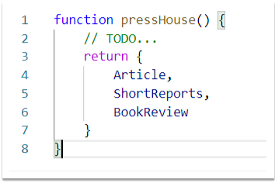

Examples
This is an example how the code is intended to be used:
Sample code usage
let classes = solveClasses();
let lorem = new classes.Article("Lorem", "Lorem ipsum dolor sit amet, consectetur adipiscing elit. Fusce non tortor finibus, facilisis mauris vel…");
console.log(lorem.toString());
------------------------------
let short = new classes.ShortReports("SpaceX and Javascript", "Yes, its damn true.SpaceX in its recent launch Dragon 2 Flight has used a technology based on Chromium and Javascript. What are your views on this ?", { title: "Dragon 2", author: "wikipedia.org" });
console.log(short.addComment("Thank god they didn't use java."))
short.addComment("In the end JavaScript"s features are executed in C++ — the underlying language.")
console.log(short.toString());
------------------------------
let book = new classes.BookReview("The Great Gatsby is so much more than a love story", "The Great Gatsby is in many ways similar to Romeo and Juliet, yet I believe that it is so much more than just a love story. It is also a reflection on the hollowness of a life of leisure. ...", { name: "The Great Gatsby", author: "F Scott Fitzgerald" });
console.log(book.addClient("The Guardian", "100 symbols"));
console.log(book.addClient("Goodreads", "30 symbols"));
console.log(book.toString());

Corresponding output
Title: Lorem
Content: Lorem ipsum dolor sit amet, consectetur adipiscing elit. Fusce non tortor finibus, facilisis mauris vel, ultricies est. Phasellus id pellentesque risus. Morbi aliquet at lectus ac malesuada. Morbi eu erat orci. Donec id turpis elit. Donec iaculis sapien odio, sit amet cursus lacus rutrum sit amet. Cras ac urna sapien. Pellentesque porta mauris ac dolor commodo, congue condimentum orci varius. Ut ultrices pretium commodo. Aenean facilisis mattis facilisis.
----------------------
The comment is added.
Title: SpaceX and Javascript
Content: Yes, its damn true.SpaceX in its recent launch Dragon 2 Flight has used a technology based on Chromium and Javascript. What are your views on this ?
Original Research: Dragon 2 by wikipedia.org
Comments:
Thank god they didn't use java.
In the end JavaScript's features are executed in C++ — the underlying language.
----------------------
The Guardian has ordered a review for The Great Gatsby
Goodreads has ordered a review for The Great Gatsby
Title: The Great Gatsby is so much more than a love story
Content: The Great Gatsby is in many ways similar to Romeo and Juliet, yet I believe that it is so much more than just a love story. It is also a reflection on the hollowness of a life of leisure. ...
Book: The Great Gatsby
Orders:
The Guardian - 100 symbols
Goodreads - 30 symbols

Problem 3. Bank
class Bank {
// TODO: implement this class...
}

Your Task
Write a Class Bank, Which Implements the Following Functionality:

Functionality

constructor (bankName)
Receives 1 parameter at initialization of the class (bankName), and should be set as private property.
Should have these 2 properties:
- bankName - private property of type string
- allCustomers - initially an empty array

newCustomer (customer)
The customer is of type object {firstName, lastName, personalId}.
- Check if the customer is already a customer of the bank. If so you should throw an Error:
”{firstName} {lastName} is already our customer!”
- Otherwise this function should add the customer as new one and return the customer details.

depositMoney (personalId, amount)
Both the personalId and the amount are numbers.
- Check if the given personalId corresponds to a customer in the customers array, if not throw a new error:
“We have no customer with this ID!”
- Otherwise add the amount to the corresponding customer in a property named totalMoney and store the transaction information to this customer (for more clarity see the example below and the hints), then return the total money of the corresponding customer and a dollar sign:
“{totalMoney}$”

withdrawMoney (personalId, amount)
Both the personalId and the amount are numbers.
- Check if the given personalId corresponds to a customer in the customers array, if not throw a new error:
“We have no customer with this ID!”
- If there is a customer with the given personalId, check if the customer has enough money in his account, to withdraw the given amount. If the money is not enough throw a new error:
“{firstName} {lastName} does not have enough money to withdraw that amount!”
- Otherwise subtract the amount from the totalMoney of the customer and store the transaction information to this customer, then return the total money of the corresponding customer and a dollar sign:
“{totalMoney}$”

customerInfo (personalId)
The personalId is of type number.
- Check if the given personalId corresponds to a customer in the customers array, if not throw a new error:
“We have no customer with this ID!”
- Otherwise return the whole information for the customer in the following format:
“Bank name: {bankName}
Customer name: {firstName} {lastName}
Customer ID: {personalId}
Total Money: {totalMoney}$
Transactions:
n. {firstName} {lastName} made deposit of {amount}$!
...
- {firstName} {lastName} withdrew {amount}$!
- {firstName} {lastName} made deposit of {amount}$!”

Transaction information contains information about:
- number of the transaction in descending order;
- names (firstName, lastName);
- if the transaction is deposit/withdraw;
- amount of the transaction.

Examples
This is an example how the code is intended to be used:
Sample code usage
let bank = new Bank("SoftUni Bank");

console.log(bank.newCustomer({firstName: "Svetlin", lastName: "Nakov", personalId: 6233267}));
console.log(bank.newCustomer({firstName: "Mihaela", lastName: "Mileva", personalId: 4151596}));

bank.depositMoney(6233267, 250);
console.log(bank.depositMoney(6233267, 250));
bank.depositMoney(4151596,555);

console.log(bank.withdrawMoney(6233267, 125));

console.log(bank.customerInfo(6233267));

Corresponding output
{ firstName: "Svetlin", lastName: "Nakov", personalId: 6233267 }
{ firstName: "Mihaela", lastName: "Mileva", personalId: 4151596 }
500$
375$
Bank name: SoftUni Bank
Customer name: Svetlin Nakov
Customer ID: 6233267
Total Money: 375$
Transactions:
3. Svetlin Nakov withdrew 125$!
2. Svetlin Nakov made depostit of 250$!
1. Svetlin Nakov made depostit of 250$!

GOOD LUCK!😊

